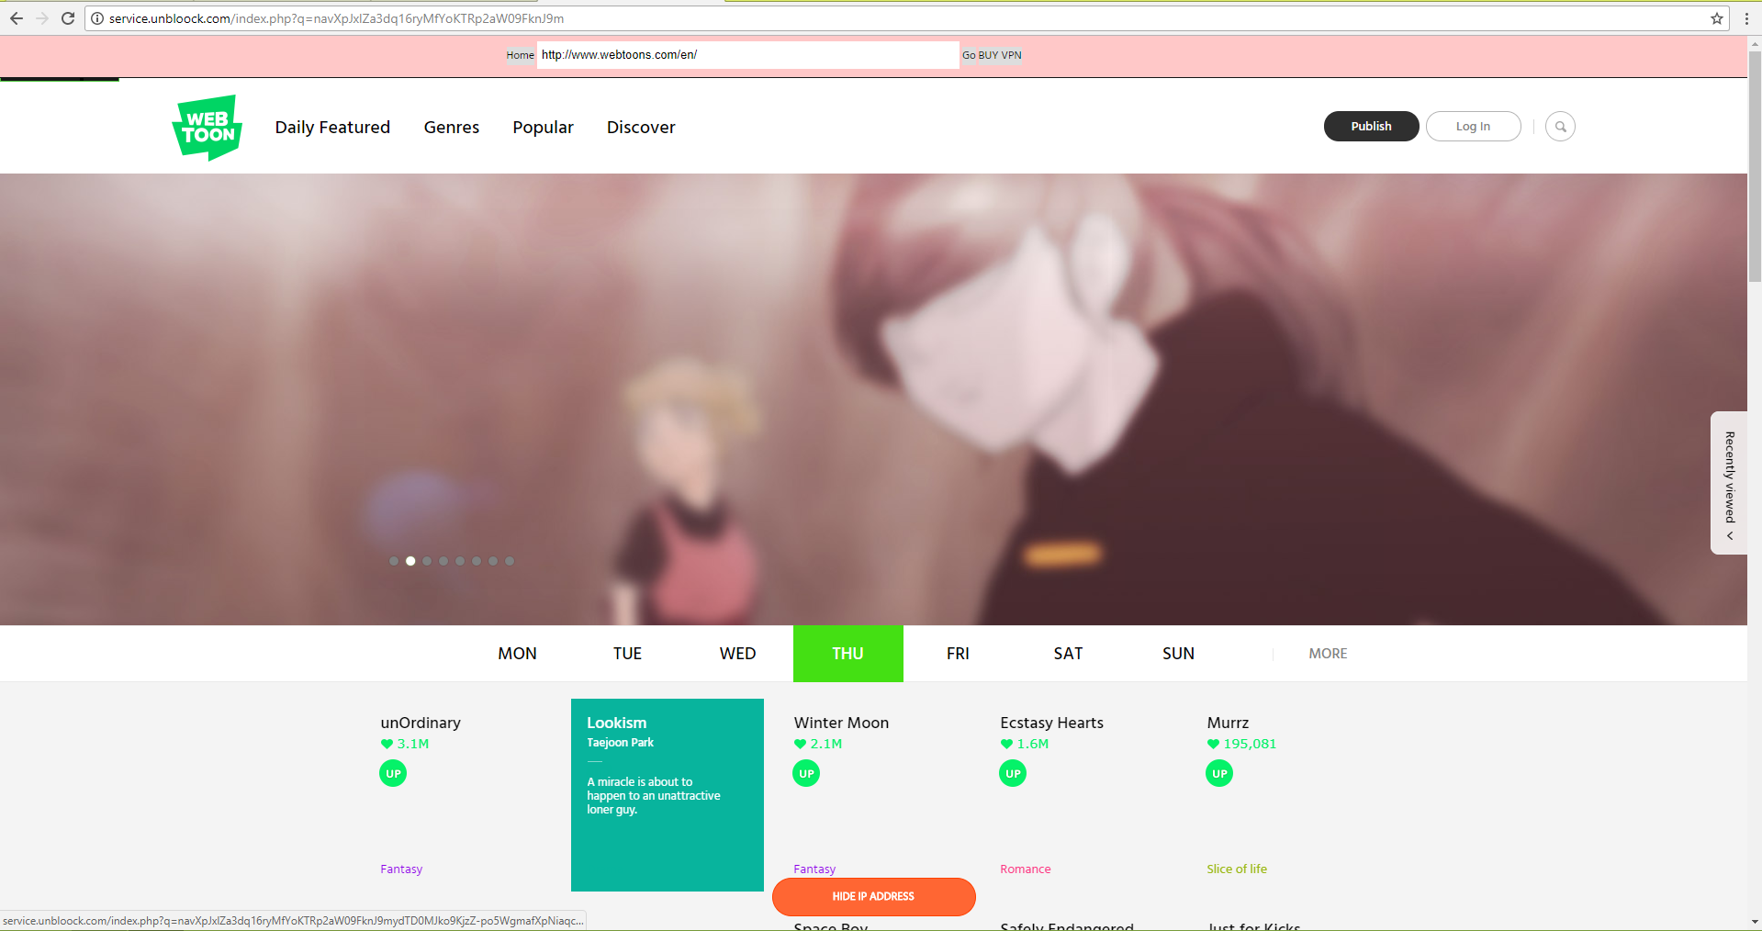
1. Main Page
This is where they advertise the latest releases
Second page
One of the top manga
Below is where you browse comics. Top comics are shown on top like these 4
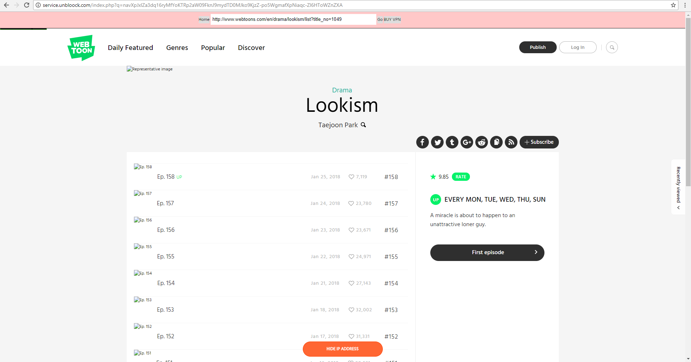
These 2 pages has a very user-friendly layout. It's easy enough for users to navigate through these pages.
Clicking this will direct you to the first episode. Much easier than scrolling down
All episodes are listed here

2. Main page
They should've just sorted these things instead of listing all of them down
Score board should be organized and arranged by teams
This should occupy a bigger space instead of being compressed
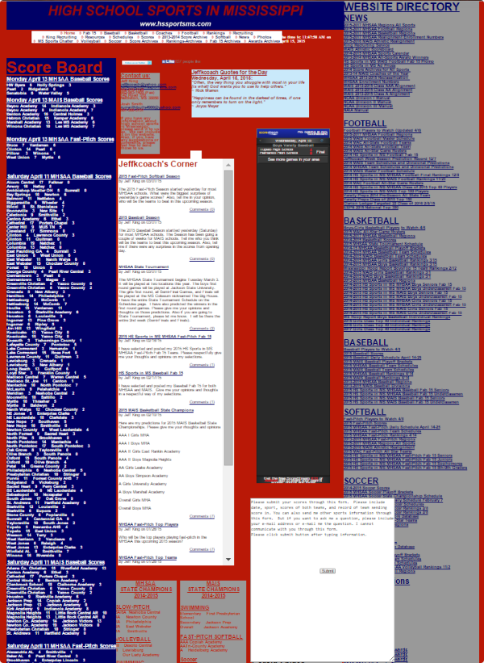
Also bad color choice.

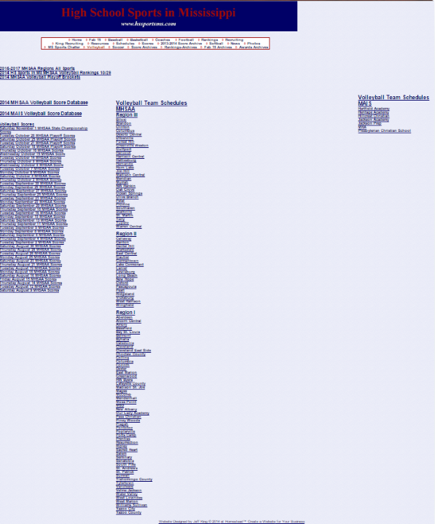
Too much wasted space
These should also be arranged and organized instead of listing everything down
Dark colors. People with poor eyesight would be having a hard time.

- To have at least a good web design, I think the layout shouldn't be too much, as it is very hard to search things if there are a lot of things being shown in one page. Color choice should also be gentle for the eyes, since different kinds of people visit the website. To have a good website shouldn't also have a lot of animations, because having a lot of animations being played would make the page very busy, making the “pretty animations” really annoying.
- www.webtoons.com is a very user-friendly website and doesn't have much complicated things that might confuse the user. And since the front page has its top comics shown and once you've decided to read one, it has a button on the right side where it takes you to the very first episode of that certain comic/manga.

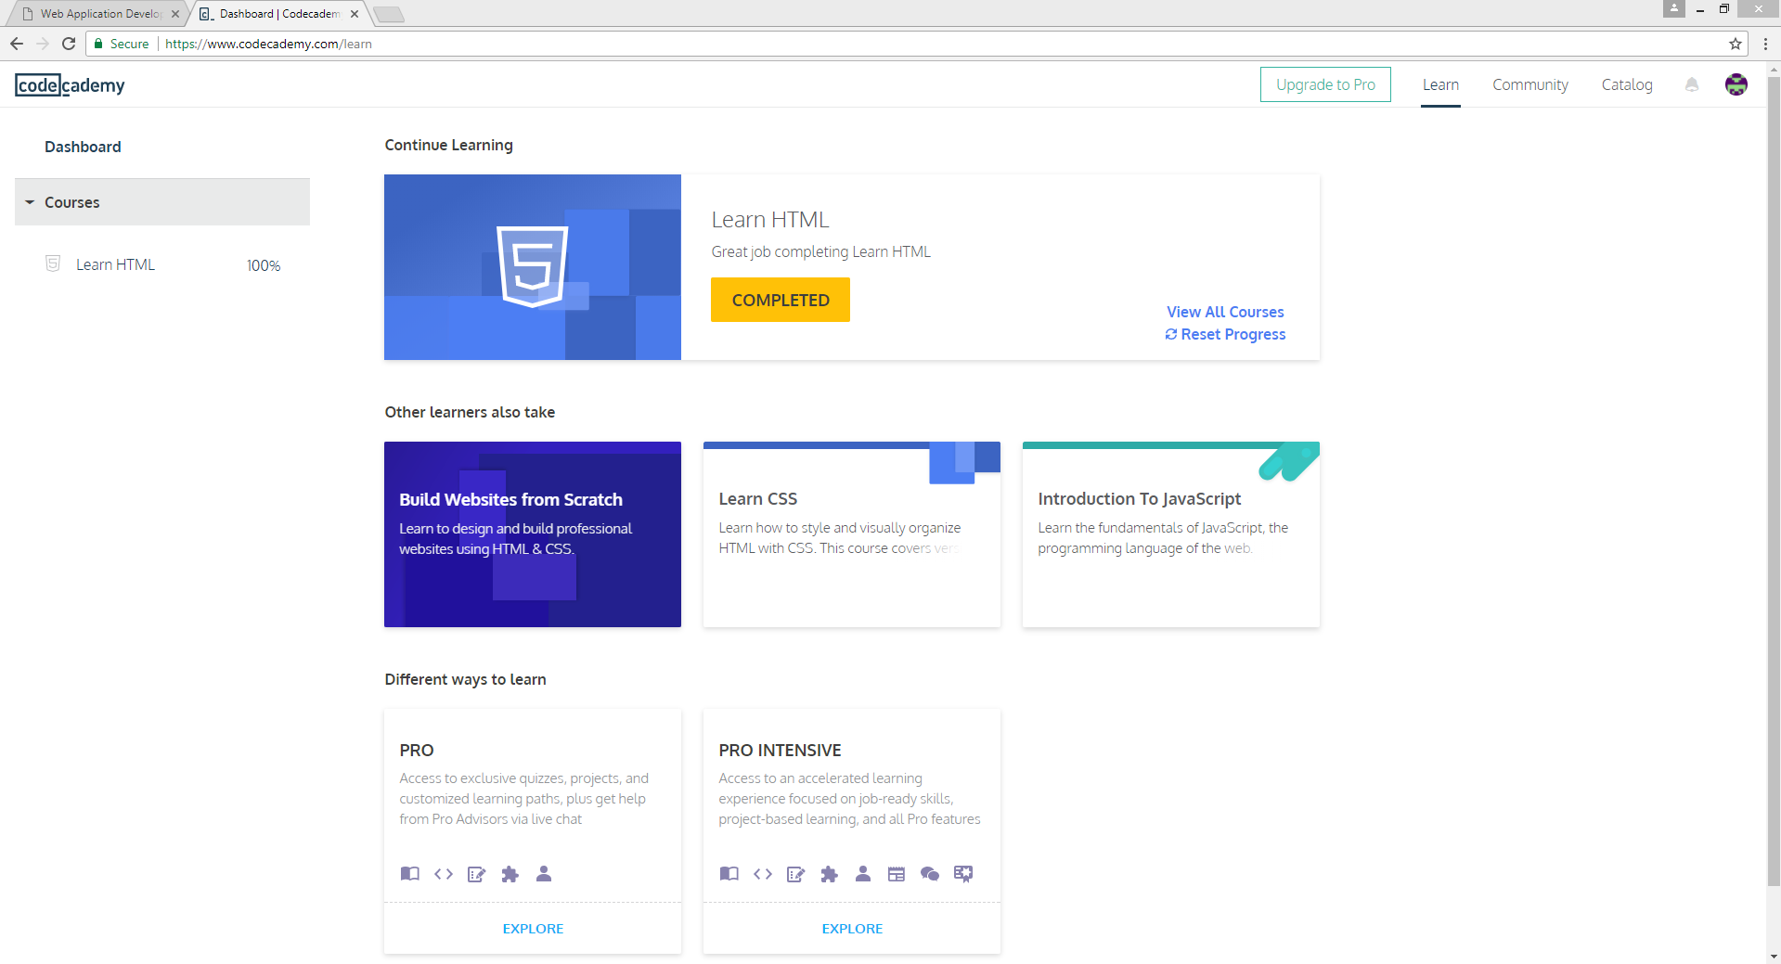
I think codecademy.com should include things like friends and stuffs like ability to message their own teacher for them to be able to have a feedback even when at home.
Codecademy.com should also provide more free lessons and less trials for students to be able to learn more and just add a donation button.

